NAME: login ID: precept #:

COS 226 Final Exam, Spring 2010
This test is 16 questions, weighted as indicated. The exam is closed book, except that you are allowed to use a one page cheatsheet. No calculators or other electronic devices are permitted. Give your answers and show your work in the space provided. Put your name, login ID, and precept number on this page (now), and write out and sign the Honor Code pledge before turning in the test. You have three hours to complete the test. "I pledge my honor that I have not violated the Honor Code during this examination."

1. MST
2. KMP
3. DFS trace
4. acronyms
5. LZW
6. TST
7. String ST
8. RE I
9. RE II
10. String sort
11. Graph algs
12. Graph memory
13. 3-way
14. Tree encoding
15. TwitStream
16. Hard problems
/4
/4
/6
/7
/7 Subtotal /28
/5
/6
/6
/4
/7 Subtotal /28
/8
/5
/8
/5
/9
/9 Subtotal /44 TOTAL /100
1. MST (4 points). By reversing the sense of the comparator, you can use Prim's algorithm and Kruskal's algorithm to find the maximum spanning tree of a weighted graph. Consider the following graph:
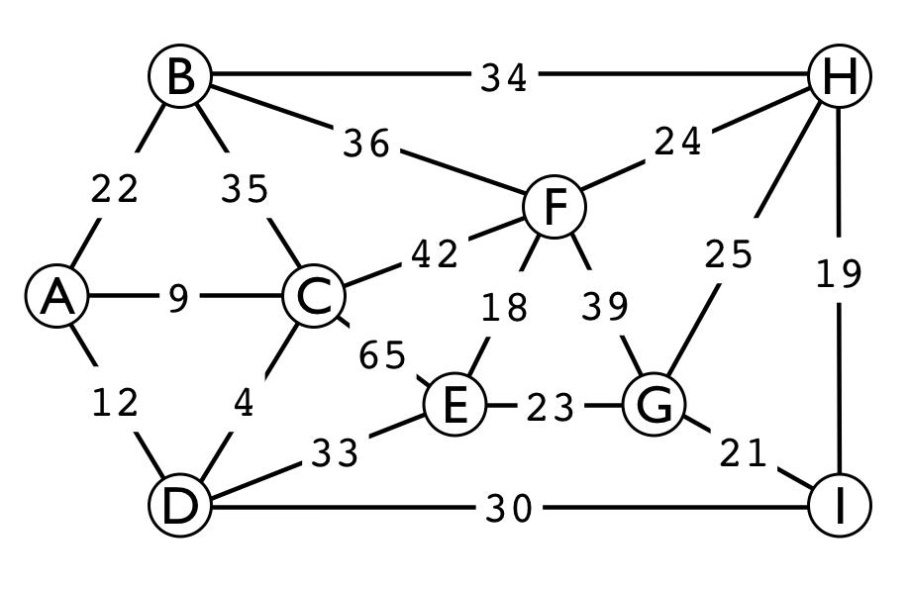
A. Give the list of edges in the maximum spanning tree in the order that Kruskal's algorithm inserts them. For reference, the 18 edge weights are listed here:
4 9 12 18 19 21 22 23 24 25 30 33 34 35 36 39 42 65
B. Give the list of edges in the maximum spanning tree in the order that Prim's algorithm inserts them, assuming that it starts at vertex A..
2. KMP (4 points). The following is a KMP state-transition table for a 9-character string.
A. Write the characters in the string in the blanks below the table.
012345678 A3 9 E2468 T1 57
___ ___ ___ ___ ___ ___ ___ ___ ___
B. Fill in the blanks in the table.
3. DFS trace (6 points). Consider the following recursive depth-first search implementation for directed graphs. Assume that Digraph G is an instance variable of the class.
private void dfs(int v)
{ marked[v] = true; for (int w : G.adj(v))
if (!marked[w]) dfs(w); }
At left is a trace of DFS for the call dfs(0) in a certain digraph (made by instrumenting the if statement to print check w for marked vertices and dfs(w) for unmarked vertices, and adding a statement to print done v as the last statement of dfs() , all with appropriate indenting). To the right of the trace, draw the digraph and give its adjacency lists. Then give a trace in the same style for the call dfs(3)in that digraph.

A (1 points). Digraph drawing B (2 points). Adjacency lists
dfs(0) dfs(1) dfs(2)
dfs(3) check 0 check 1
3 done
check 1
2 done
check 0
1 done check 2
0 done
C (3 points). Trace of dfs(3)
dfs(3)
4. Acronyms (7 points). Each of the descriptions below fits a commonly-used three-letter acronym. Write the acronym corresponding to each description in the blank to its right.
A. Abstract machine, basis for KMP algorithm. ______
B. Data structure for implementing symbol tables. ______
C. Substring-search algorithm. _KMP_
D. Fundamental recursive method. ______
E. For single-source shortest paths in unweighted graphs. ______
F. Symbol table-based compression algorithm. ______
G. Fundamental search problem, from logic. ______
H. Abstract machine, basis for grep ______
5. LZW compression (7 points). Complete the line labeled out and the following table for computing the LZW compression of the string B A N D A N A B A N A N A.
in: B A N D A N A B A N A N A out: 42 41 4E 80
key value
B A 81 82 83 84 85 86 87 88 89
6. Suffix TST (5 points). The suffix TST corresponding to a string is constructed by building the TST corresponding to the string suffixes, including on each an end-of string
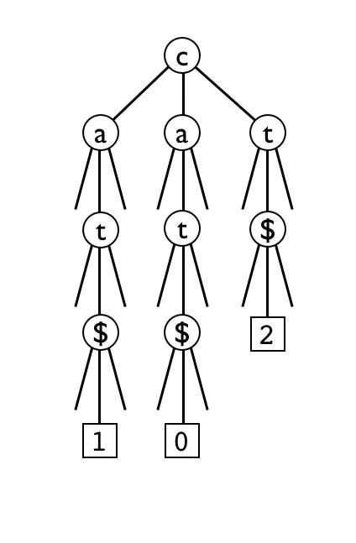
character $ that is larger than every string character. Thus, every path through the TST ends in a $, below which we put an external node corresponding to the starting point of the suffix. For example, the suffix TST corresponding to the string cat is drawn at left.
Draw the suffix TST corresponding to the string babab using the same order as the example above.
7. String symbol table (6 points). Match each of the given search data structures with one or more of the given characteristics, where N is the number of keys, L is the average number of characters in a key, and R is the size of the alphabet. Write as many letters (in alphabetical order) as apply in the blank to the left of the name of the data structure. Assume that the keys were inserted in random order. The average search time referred to in B, D, and E is for a random successful search (assuming that each key in the structure is equally likely to be the search key).
A. tree/trie shape is dependent on the order in which keys are inserted
B. average search time is ~clog N for some constant c
C. space usage is ~cNR for some constant c
D. average search time ~cL for some constant c
E. asymptotic average search time cannot be determined from the information given
________ R-ary trie
________ BST
________ TST
________ red-black tree

8. RE pattern matching I (6 points). Draw an NFA (nondeterministic finite state automata) that recognizes the same language that the regular expression ((AB* | C )* | D* ) describes. Use the notation and construction given in lecture and the book (if you don't have a red pencil, mark epsilon transitions as dotted lines). Circle your final answer.
9. RE pattern matching II (4 points). Why do we not use a DFA (deterministic finite state automata) instead of an NFA (nondeterministic finite state automata) to implement RE pattern matching? Circle one of the following choices.
A. NFAs are easier to simulate than DFAs.
B. More than one DFA might correspond to each RE.
C. We do not know how to compute a DFA corresponding to a given RE.
D. We do know how to compute a DFA corresponding to a given RE, but not one guaranteed to have a reasonable number of states.
E. NFAs lead to simpler code.
10. 7 sorting algorithms (7 points). The leftmost column is the original input of strings to be sorted, and the rightmost column is the sorted result. The other columns are the contents at some intermediate step during one of the 7 sorting algorithms listed below. Match up each algorithm by writing its letter under the corresponding column. Use each letter

exactly once.
swab ably abba ably ably abba abet ably abba ably babe ably abys babe baba ably babe abed babe able abut abba able swab babe swab abet wabs blab abys abut blab blab able wabs able blab cabs babe abed cabs drab blab baby ably cabs baby baby abet baby flab cabs blab abut baby dabs blab able dabs slab baby cabs abys dabs abys cabs babe abys grab dabs dabs baba abys drab dabs blab drab crab abys abys babe drab flab drab baby flab scab drab drab baby flab abba flab baba sabs stab flab flab blab sabs gabs gabs cabs abba abed sabs sabs cabs abba abut sabs crab gabs babe abba abba crab gabs baba swab dabs abut able gabs abut dabs abut gaby wabs drab baba wabs abut baba drab baba grab baba flab gaby cabs baba gabs flab gaby jabs gaby gabs slab dabs gaby gaby gabs slab labs grab gaby grab abys slab grab gaby grab abed jabs grab stab sabs grab slab grab tabu nabs labs jabs jabs gabs stab tabu jabs jabs crab slab labs labs jabs jabs abed labs labs abet tabu nabs abed labs labs jabs nabs abed sabs abed swab nabs nabs abed labs sabs nabs stab abet sabs crab tabs nabs nabs scab crab swab able slab scab abut crab abet slab scab scab crab scab abet abet scab crab stab abet slab nabs stab swab tabu swab scab swab stab tabs scab tabu tabs ably tabu stab tabs tabs tabu stab tabs tabu baby tabs able tabu able wabs tabs wabs wabs gaby wabs tabs wabs
____ ____ ____ ____ ____ ____ ____
A. Mergesort
B. MSD string sort
C. LSD string sort
D. Quicksort (with no random shuffle)
E. Bottom-up mergesort
F. Quicksort with 3-way partitioning (with no random shuffle)
G. 3-way string quicksort
11. Graph algorithms (8 points). Match each of the ideas listed below to the named algorithms by writing a letter to the left on each algorithm name. Two letters get used twice; one blank gets two letters.
A. Relax edges until no relaxation is possible.
B. Sort edges by their weight, then check connectivity.
C. Keep vertices for which the DFS is not yet complete on a stack.
D. Use DFS of the reverse digraph to provide a vertex-checking order for a standard DFS.
E. Put vertices on a stack just before completing a recursive DFS.
F. Add vertices one by one to a growing tree.
______ Prim
______ Kosaraju
______ Bellman-Ford
______ Directed cycle detection
______ Topological sort
______ Kruskal
______ Dijkstra
12. Graph space usage (5 points). Analyze the following code in terms of its memory usage with respect to V (number of vertices) and E (number of edges). For partial credit, make sure to fill in the blanks to the right of each declaration with its associated memory usage. Assume that object overhead is 8 bytes , that int values and references use 4 bytes, and that an Integer is 12 bytes. Note that the graph is undirected. Make sure that your final answer is concise and clear.
public class Graph
{ private final int V; ________ private final Bag<Integer>[] adj; ________ public Graph(int V) {
this.V = V; adj = (Bag<Integer>[]) new Bag[V]; for (int v = 0; v < V; v++) adj[v] = new Bag<Integer>();
} public void addEdge(int v, int w) { adj[v].add(w); adj[w].add(v); }
... } public class Bag<Item> {
private Node first = null; private class Node ________ { Item item; Node next; } public void add (Item item) {
Node oldfirst = first; first = new Node(); first.item = item; first.next = oldfirst;
} ...
}
Total memory usage for graph with V vertices and E edges ________________________
13. 3-way partitioning (8 points). Consider running the 3-way partitioning algorithm we studied in class on a (sub-)array of length N. Assume that elements less than, equal to, and greater than the pivot are distributed uniformly throughout the array (i.e., if there are k elements greater than the pivot, then ~k/2 of them are in each half of the array, ~k/4 are in each quarter, and so on). Give the expected number of compares and exchanges performed by the algorithm in each of the following scenarios. Use tilde notation, so that you can give answers like ~N/3 and ~N instead of exact answers like N -1 or N/2 + 1.
A. Half of the elements in the array are less than the pivot element, while half are greater (and none are equal).
Compares: _____~N______ Exchanges:_____________
B. Half of the elements in the array are equal to the pivot element, while a quarter are less and a quarter are greater.
Compares: _____________ Exchanges:_____________
C. All of the elements in the array are equal to the pivot element.
Compares: _____~N______ Exchanges:_____0______
Now consider an alternative partitioning algorithm that operates as follows: First, perform a 2-way partition on the array, in which the scans do not stop on elements equal to the pivot. This gives you two parts, with elements <= and >= the pivot. Then, perform a 2-way partition on just the first part of the array (elements classified as <= the pivot), modified so that elements equal to the pivot are moved to the end (of that part of the array), while elements strictly less than the pivot are moved to the beginning. Similarly, partition the second part of the array, moving the elements greater than the pivot to the end and elements equal to the pivot to the beginning. Just as with the algorithm from class, the result should be that elements less than the pivot are at the beginning, equal in the middle, and greater at the end. Give the expected number of compares and exchanges carried out by this algorithm under scenarios A, B, and C above.
D. (scenario A) Compares: ___________ Exchanges:_____________
E. (scenario B) Compares: ___________ Exchanges:_____________
F. (scenario C) Compares: ___________ Exchanges:______0______
14. Tree encoding (5 points). A binary tree with leaves is a binary tree where null links only appear in leaves, which are nodes with both links null. A preorder encoding of a binary tree with leaves is created by traversing the tree in preorder, writing 0 when an internal node is first encountered and 1 when a leaf is first encountered. This encoding is like the encoding we used in Huffman encoding, omitting the character codes.
A. (2 points) Using circles for internal nodes and squares for leaves, draw the tree encoded by
0 0 0 1 1 1 0 1 0 0 1 1 1
B. (3 points) Give a simple rule for determining whether a binary string is a legal preorder encoding of a binary tree with leaves. Your answer should be one or two sentences.
15. Burrows-Wheeler (9 points). Your first task at a hot new startup is to make a newly acquired whole-Twitter-archive called the TwitStream easily searchable: for any given query string, you are to return the number of instances of that query string in the TwitStream. Since Twitter is highly repetitive and the TwitStream is extremely large, it is critical that clients can count the number of occurrences in time proportional only to the length of the query string, without any dependence on the number of occurrences of query string. Luckily for you, when you were doing your Burrows-Wheeler assignment in COS 226 you noticed a way that the BWT could be used to solve the problem, as long as you have the following data structures, which can be computed in a single preprocessing pass through the TwitStream requiring time and space proportional to its length.
s[i] = character i in the sorted list i = 0...N-1
t[i] = character i in the Burrows Wheeler Transform i = 0...N-1
sIndex[c] = first index of s that contains character c c = 0...R-1, with sIndex[R] = N
tCount[c,i] = count of char c from t[0] ... t[i] i= -1...N-1, c = 0...R-1
A B R A C A D A B R A ! tCount[,]
i | s | Sorted Suffixes (fyi) | t | ! A B C D R
-- | - | ---------------------- |  | ----------
-1 |  |  |  | 0 0 0 0 0 0
0 | ! | ! A B R A C A D A B R A | A | 0 1 0 0 0 0
1 | A | A ! A B R A C A D A B R | R | 0 1 0 0 0 1
2 | A | A B R A ! A B R A C A D | D | 0 1 0 0 1 1
3 | A | A B R A C A D A B R A ! | ! | 1 1 0 0 1 1
4 | A | A C A D A B R A ! A B R | R | 1 1 0 0 1 2
5 | A | A D A B R A ! A B R A C | C | 1 1 0 1 1 2
6 | B | B R A ! A B R A C A D A | A | 1 2 0 1 1 2
7 | B | B R A C A D A B R A ! A | A | 1 3 0 1 1 2
8 | C | C A D A B R A ! A B R A | A | 1 4 0 1 1 2
9 | D | D A B R A ! A B R A C A | A | 1 5 0 1 1 2
10 | R | R A ! A B R A C A D A B | B | 1 5 1 1 1 2
11 | R | R A C A D A B R A ! A B | B | 1 5 2 1 1 2

sIndex[] 0 1 6 8 9 10 12
Your task is to figure out how to use these data structures to perform substring search queries in time proportional to the length of the query string, by answering the questions on the next page.
A. (1 point) The entry tcount[c, N-1] gives the number of occurrences of search string that consists of a single char c. Give another expression for that value. Answer with one line of code.
B. (2 points) All suffixes that start with the same string will sort to consecutive indices. Suppose that for a string S, you know that the first index that starts with that string is first and that the last index that starts with that string is last. How many occurrences are there of the string cS, which is the string S prefixed by the char c? Assume that cS appears in the TwitStream. Answer with one line of code involving first,last,tCount, and c. Be careful with the indices!
C. (2 points) Suppose that you know that the first suffix that starts with the string S has index first . If you add the single char c to the front of the string S, to make a new string cS, what is first_cs, the first index of the a suffix that starts with cS? Answer with one line of code.
D. (1 point) Similarly, if for a string S you know that the largest index of a suffix that starts with S is last, what is the last index, last_cs, of the string cS? Answer with one line of code.
E. (3 points) How can you calculate the number of occurrences of a string in time proportional to its length? Answer with two or three sentences.
16. Hard problem identification (9 points). This question is in regard to your new job working for a software technology company. Your boss (having been told by you on the basis on your 126 knowledge that the company had better not bet its future on developing an application that finds an optimal tour connecting a set of cities) is still looking for a challenging project for you. Your boss is willing to invest in trying to solve problems that might be difficult, but not problems that we know to be impossible to solve or that we believe to be intractable. On the basis of your 226 knowledge, which of the following ideas can you tell your boss to forget about? Circle all that apply.
A. A regular expression that describes strings with balanced parentheses
B. An algorithm that guarantees to compress any given file by at least one percent
C. A linear-time algorithm for finding the convex hull of a set of points in the plane that can only compare the distances between two points
D. A linear-time algorithm for finding the MST of a graph with positive edge weights
E. A linear-time algorithm for sorting an array of double values.
F. A fast poly-time algorithm for bipartite matching
G. A fast poly-time algorithm for finding a maximal set of vertices in a graph such that no two of them are connected by an edge.
H. A linearithmic algorithm for finding one triple a, b, csuch that a*b=cin an array of doublevalues.
I. A linear-time algorithm for the maxflow problem.

